**DOMINION ONLINE**

**PROJECT MANAGEMENT PLAN**

CMSC 495

University of Maryland University College

Group 4

Team Member 1: Byong Park

Team Member 2: Thomas Lee

Team Member 3: Jennifer Sutton

Team Member 4: Matthew Hayes

Team Member 5: Joshua Piersol

**PREFACE**

This Project Management Plan (PMP) is intended to provide guidance on the management of the Dominion Online Project.

**DOCUMENT CONVENTIONS**

The outline of this Project Management Plan (PMP) has been tailored from the Institute of Electrical and Electronics Engineers (IEEE) Standard for Software Project Management Plans, IEEE Std 1058-1998. RECORD OF CHANGES

*A - ADDED M - MODIFIED D – DELETED

|  |  |  |  |  |  |
| --- | --- | --- | --- | --- | --- |
| VERSION NUMBER | DATE | NUMBER OF FIGURE, TABLE OR PARAGRAPH | **A* M D** | TITLE OR BRIEF DESCRIPTION | CHANGE REQUEST NUMBER |
| 1.0 | 3/23/2018 |  | A | Initial Version |  |
| 1.1 | 5/5/2018 |  | M | Updated Technical Process |  |
|  |  |  |  |  |  |
|  |  |  |  |  |  |
|  |  |  |  |  |  |
|  |  |  |  |  |  |
|  |  |  |  |  |  |
|  |  |  |  |  |  |
|  |  |  |  |  |  |
|  |  |  |  |  |  |
|  |  |  |  |  |  |
|  |  |  |  |  |  |
|  |  |  |  |  |  |
|  |  |  |  |  |  |
|  |  |  |  |  |  |
|  |  |  |  |  |  |
|  |  |  |  |  |  |
|  |  |  |  |  |  |
|  |  |  |  |  |  |
|  |  |  |  |  |  |
|  |  |  |  |  |  |
|  |  |  |  |  |  |
|  |  |  |  |  |  |
|  |  |  |  |  |  |
|  |  |  |  |  |  |
|  |  |  |  |  |  |

**TABLE OF CONTENTS**

**Section Page**

SECTION 1. OVERVIEW 5

1.1 Project Summary 5

1.1.1 Purpose, Scope, and Objectives  5

1.1.2 Assumptions and Constraints  5

1.1.3 Project Deliverables  5

1.1.4 Master Schedule and Budget Summary  5

1.2 Evolution of the Plan 6

1.3 Document Structure 6

SECTION 2. DEFINITIONS 7

SECTION 3. PROJECT ORGANIZATION 8

4.1 External Interfaces 8

4.2 Internal Structure 8

4.2.1 The Project Manager  8

4.3 Project Roles and Responsibilities 8

SECTION 4. TECHNICAL PROCESS 10

6.1 Process Model 10

6.2 Methods, Tools and Techniques 11

6.3 Project Infrastructure 11

6.4 Product Acceptance 11

# SECTION 1. OVERVIEW

## 1.1 PROJECT SUMMARY

The project is an online implementation of the card game Dominion. It will include only the base game and will allow multiple people to play the game together.

### 1.1.1 Purpose, Scope, and Objectives

The scope of the project is a website that allows multiple people to play Dominion together. Upon visiting the website, users will be able to join a queue, which will create game sessions once another player has joined. Users will then be presented with a view of the board and be allowed to take turns submitting moves until the victory conditions have been met. Once they have completed the game, they will be returned to the original screen so they can join the queue again. Multiple games will be running at the same time.

### 1.1.2 Assumptions and Constraints

As there is a significant time constraint on this project, only the base game cards will be implemented.

### 1.1.3 Project Deliverables

This project will include the following deliverables no later than May 6, 2018:

* Project Plan
* Requirements Specification
* System Specification
* User's Guide
* Test Plan and Results
* Design and Alternate designs
* Development History
* Conclusions
* Source code for Website and Server

### 1.1.4 Master Schedule and Budget Summary

The project is expected to be delivered as follows:

* Project Plan: 03/25/18
* Requirements Specification: 03/25/18
* System Specification: 03/25/18
* User's Guide: 04/01/18
* Test Plan and Results: 04/01/18
* Design and Alternate designs: 04/08/18
* Development History: 05/06/18
* Conclusions: 05/06/18
* Source code for Website and Server
  + Frontend: 04/29/18
  + Backend: 05/06/18

## 1.2 EVOLUTION OF THE PLAN

Every week, team members will work on individual pieces of the project and routinely upload their work to a central repository for the rest of the team to access. Team members will regularly converse using Discord to stay up to date on the plan.

## 1.3 DOCUMENT STRUCTURE

This plan is organized as follows:

1. Section 1, Project Overview. This section provides an overview of the scope and objectives of the project, the project’s assumptions and constraints, reference to the project deliverables, schedule and budget, and a description of the evolution of the plan.
2. Section 2, References. This section provides a list of all documents, policies, templates, processes, and other sources of information referenced in the plan.
3. Section 3, Definitions. This section contains the abbreviations and acronyms required to properly understand this planning document.
4. Section 4, Project Organization. This section identifies interfaces to organizational entities external to the project, the project’s internal organizational structure, and defines roles and responsibilities for the project.
5. Section 5, Technical Process. This section describes the technical solution in terms of a process model and implementation methods, tools, and techniques to be used to develop the various work products, plans for establishing and maintaining the project infrastructure, and the product acceptance.

# SECTION 2. DEFINITIONS

**Player -** A player is an individual who is playing the game. Each player has a deck of cards, a discard pile, and a current hand.

**Card** - A card in Dominion has a ***name****,* ***cost****,* ***type****, and* ***ability*.** The card’s name is its identifier - that is, given a card’s name one can determine its cost, type, and ability. Each card has a **cost,** which is deducted from the player’s current **gold** when it is played.

**Type** - A card’s type (e.g. Action, Treasure, or Victory) determines which phase it can be played. An Action card may be played during the player’s Action phase, and a Treasure card may be played during the Buy phase.

**Action Card** - A card with the **Action** type can only be played during the first phase of a player’s turn (the Action phase). Each action card has a unique **ability** which affects the game in some way.

**Treasure Card** - A card with the **Treasure** type can be played during the second phase of a player’s turn (the Buy phase). Each treasure card played increments the player’s current gold total by the card’s value. When a player has enough gold, they may purchase a card from the supply. This purchased card is then put into the discard pile (becoming available on subsequent turns).

**Victory Card** - A card with the **Victory** type contributes to a player’s final score. The objective of Dominion is to acquire as many Victory points as possible - each victory card contributes between 1-6 points towards this total (Estates are worth 1 point, Duchies are worth 3, and Provinces are worth 6).

**Reaction Card -** A card with the **Reaction** type is played in response to something else happening such as an opponent playing a certain type of card. The card has to be in the player’s hand to be activated.

**Supply** - The supply consists of all the cards a player is able to buy in a game. The amount of each cards in each supply pile is finite and depends on the card. When a certain amount of piles or the Province pile is depleted, the game ends.

# SECTION 3. PROJECT ORGANIZATION

## 3.1 EXTERNAL INTERFACES

The only external interface for this project is the professor.

## 3.2 INTERNAL STRUCTURE

The internal structure of this project will be made up of five team members. Each team member will be responsible for their own section of the project and will work with other team members to make sure that their section works with the other team members’ sections.

## 3.3 PROJECT ROLES AND RESPONSIBILITIES

|  |  |  |  |
| --- | --- | --- | --- |
| Task Name | Start Date | End Date | Team Member(s) |
| Requirements Specification | 03/18/18 | 03/25/18 | Byong Park |
| System Specification | 03/18/18 | 03/25/18 | Byong Park |
| Project Plan | 03/18/18 | 03/25/18 | Jennifer Sutton & Matt Hayes |
| User Guide | 03/25/18 | 04/01/18 | Matt Hayes |
| Test Plan | 03/25/18 | 04/01/18 | Joshua Piersol |
| Project Design | 04/01/18 | 04/08/18 | Matt Hayes |
| Game Server for all games | 04/08/18 | 04/15/18 | Byong Park |
| Event Queue for individual games | 04/08/18 | 04/15/18 | Jennifer Sutton |
| Rules Engine | 04/08/18 | 04/15/18 | Jennifer Sutton |
| Treasure Cards | 04/08/18 | 04/15/18 | Jennifer Sutton |
| Victory Cards | 04/08/18 | 04/15/18 | Jennifer Sutton |
| Database to manage each game | 04/08/18 | 04/22/18 | Matt Hayes |
| Text/Form-based Interface | 04/08/18 | 04/22/18 | Byong Park/Thomas Lee |
| Simple Action Cards | 04/15/18 | 04/22/18 | Jennifer Sutton |
| Complex Action Cards | 04/15/18 | 04/29/18 | Jennifer Sutton |
| Skeleton of Progressive Web Application (PWA) | 04/22/18 | 05/06/18 | Byong Park/Thomas Lee |
| PWA Images/Vector Art and Other assets  Sound design/Music | 04/29/18 | 05/06/18 | Joshua Piersol   Thomas Lee |
| Testing | 04/29/18 | 05/06/18 | Joshua Piersol |
| Conclusions | 04/29/18 | 05/06/18 | Everyone |
| Development History | 04/29/18 | 05/06/18 | Everyone |

# SECTION 4. TECHNICAL PROCESS

## 4.1 PROCESS MODEL

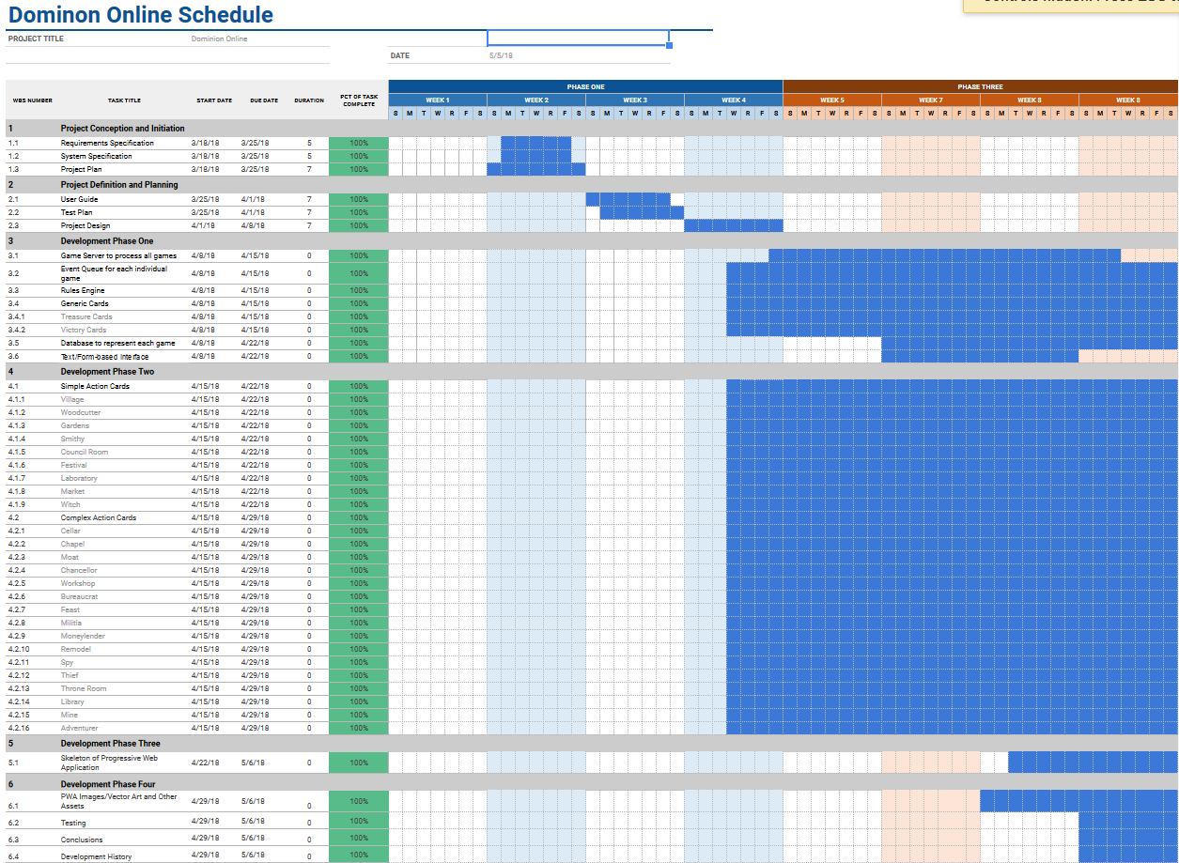

**4.2 METHODS, TOOLS AND TECHNIQUES**

The backend of the project will be written in Python 3.6 and will use Flask to handle requests from the web application.

The frontend of the project will use HTML, Javascript, and CSS. It will be a progressive web application that connects the game server using Python and websockets.

## 4.3 PROJECT INFRASTRUCTURE

Each team member will use a development environment of their choice but they will test it with the same production server that is running Debian 9.4.

## 4.4 PRODUCT ACCEPTANCE

The project will be deemed complete when it meets all of the requirements. Throughout the development of the project, it will be tested to verify that it satisfies them. Testing procedures will continually be developed to test each requirement. The testing procedures themselves will be reviewed at the end of the project to make sure every requirement is tested for.